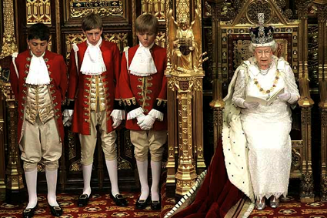

BONFIRE NIGHT

Every year British people make bonfires on 5th November, called “Bonfire Night”. They celebrate the anniversary of the Gunpowder Plot. They remember that, in 1605, a man called Guy Fawkes and a group of plotters tried to blow up the Houses of Parliament in London. On that date the King and his leaders were opening the Parliament, an annual ceremony that takes place every November. Guy Fawkes wanted to kill the King James I. They were discovered, tortured and executed.

Nowadays on Bonfire Night people light bonfires, let off fireworks, eat warm Bonfire Night food, like sausages and jacket potatoes and celebrate that the king was not killed.

During the days before Bonfire Night, children make a life-sized effigy of Guy Fawkes, called “GUY”, by stuffing old clothes with newspapers. They put it in prams and on the streets they ask for money saying “A penny for the guy”. Adults give them money and then they spend it on sparkles and sweets. They put the guy on the bonfire and burn it.

Every year the Queen Elisabeth II travels on a coach drawn by four horses from Buckingham Palace to Westminster for the State Opening of the Parliament

Laura Briz Romero
lbriz@e-quercus.es
ESO 4

