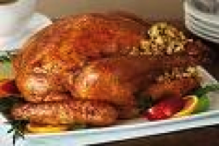

The Thanksgiving day in the USA

The Thanksgiving Day is the most familiar day in the year. Everybody is gathered with his friends or family to celebrate a great meal together. In the past the thanksgiving day was to give thanks to good, but now it is known for its succulent dinners. The day of turkey was also other name because each family cooked a turkey in a special way.
The “cranberrgsauce”or “pumpkin pier” are other typical menu of thanksgiving.
There is also a traditional football match.
Each day of Thanksgiving is celebrated a party that American continue to care. The next day after the feast and rest, they go shopping. This is the so called “black Friday”, the day in the year where the most purchases occur.

Mónica López Valle
ESO 1A
Rosaura Dueñas Alonso
ESO 1A
Laura Urrutia González
ESO 1A
Fátima Santamaría Muñoz
ESO 1A

