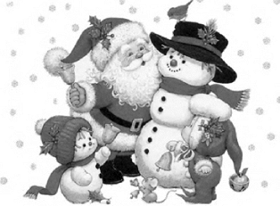

Christmas Story
The bunny fun.

A fluffy rabbit lived in the forest. One day he was sitting in the shade of a tree when a squirrel approached him.
- Hello, sir rabbit, said the squirrel. And looking toward her, she pulled out his tongue and began to run out.
- Silly, thought the squirrel.
One the way to his burrow, the rabbit met a fawn who also wanted to say hello:
- Good morning, sir rabbit. And again the rabbit pulled out his tongue and began to run.
And he always did the same when he met an animal in the forest.
One day, all the animals decided to give him a good lesson. They agreed that they mustn’t say hello when they saw the rabbit.
In the following days, the whole word ignored the rabbit. No one talked to him and no one greeted him. On day, all animals organized a party and the rabbit appeared in the middle of the party.
No body took notice of him. Then, the rabbit overwhelmed by the lack of attention of his colleagues and he decided to leave with his ears low.
The other animals called him and the rabbit promised them not to mock any more of his friends in the forest. Everybody amused on the party and they lived together very happy for ever.

Rosaura Dueñas Alonso
ESO 1A
Fátima Santamaría Muñoz
ESO 1A
Mónica López Valle
ESO 1A
Laura Urrutia González
ESO 1A

