LOVE OF COUNTRY

DRAGOSTEA DE PATRIE
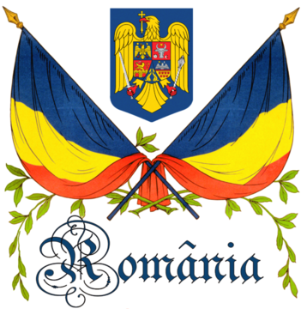
AMOR A LA PATRIA- Spanish
ЛЮБОВТА НА СТРАНАТА –Bulgarian
ΑΓΆΠΗ ΓΙΑ ΤΗΝ ΠΑΤΡΊΔΑ-Greek
AMOR DI PATRIA –Italian
RAKKAUS ISӒNMAAHAN –Finnish
LIEFDE VOOR JE LAND - Dutch
VATAN SEVGISI – Turkish

HOW TO LOVE YOUR COUNTRY

It's always good to love your country. After all, it's where you live.

There are some steps you have to consider when talking about your positive feelings towards your country; so, you will see how great your country really and truly is:

1. Be an active citizen.
Actively demonstrate your love for your country by being part of its political process. Continually strive for a better country for all!

2. Study the history of your country.
What are some of the great things people have done and how they showed their love of their country? What are some of the things people have done with good intentions but poor results? Learn from your country's history -- both the good times and the bad times.

3. Focus on current events.
For example, focus on what is also going on in the world as a whole and how your country is involved in it as well.

4. Read stories, tall tales, and patriotic legends of your country.
You will be amazed with such the creativity and imagination of those who wrote or thought up them.

5. Have a hero.
Someone who represents your country and is a good role model for you will make you proud to be where you call home.

6. Wear patriotic colors.
Nothing shows you love your country more than showing it through clothing or accessories!

7. Fly a flag.
You can purchase flags, bumper stickers, or any other emblems at a local store. Hang them on your car, your front lawn, or anywhere that can outwardly show you respect your country. Remember to treat the flag with the utmost respect.

8. Celebrate holidays.
What happened in your country on this day in history? Did they win a war? Did they gain independence? Recognize that holidays are much more than just occasions for parties or, in some countries, sales at department stores. Acknowledge the solemnity inherent to certain holidays, especially those that commemorate a victory that involved bloodshed.
History of the flags of Romania

The colors of the national flag of Romania (Romanian: Drapelul României) have a long history. Red, yellow and blue were found on late 16th-century royal grants of Michael the Brave, as well as shields and banners. During the Wallachian uprising of 1821, they were present on the canvas of the revolutionaries' flag and its fringes; for the first time a meaning was attributed to them: "Liberty (sky-blue), Justice (field yellow), Fraternity (blood red)".
The tricolor was first adopted in Wallachia in 1834, when the reforming domnitor Alexandru II Ghica submitted naval and military colors designs for the approval of Sultan Mahmud II. The latter was a “flag with a red, blue and yellow face, also having stars and a bird’s head in the middle”. Soon, the order of colors was changed, with yellow appearing in the center. When the flags were handed over for use, Ghica remarked:
“ The flags of this divinely preserved land have since antiquity been the pride of its soldiers and the symbols of its glory ... The Romanian militia, organized on the basis of European rules and discipline, once again secures this ancient right and receives its flags with the national colors and the principality’s eagle. My Lordship now entrusts to the infantry battalions and the cavalry divisions these flags as a sacred repository of gratitude, faith and obedience to the established laws... ”
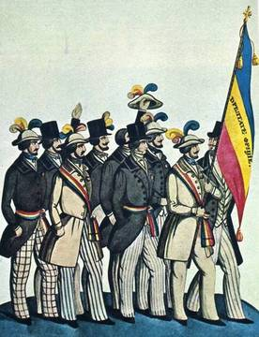
In 1840, in order to differentiate the military colors from the war flag, Ghica adopted a new design for the former: a red-yellow-blue tricolor, with red on top and stripes of equal width. In the center was a white shield bordered with gold and decorated with the Wallachian eagle, wearing the princely crown and with a cross in its beak.
In 1848, the flag adopted for Wallachia by the revolutionaries that year was a blue-yellow-red tricolor (with blue above, in line with the meaning “Liberty, Justice, Fraternity”). Already on 26 April, according to Gazeta de Transilvania, Romanian students in Paris were hailing the new government with a blue, gold and red national flag, “as a symbol of union between Moldavians and Muntenians”.

On 30 June, Metropolitan Neofit, as prime minister, gave the following disposition: “the standards of liberty will be raised on all buildings, and the insignia will be carried”. These symbols were widely employed in demonstrations and raised on public buildings, boats, warships, etc.
Nevertheless, decree nr. 252 of 13/25 July 1848, issued because “it has not [yet] been agreed how the national standards should be designed”, defined the flag as three vertical stripes, possibly influenced by the French model. The shades were “dark blue, light yellow and carmine red”; as for order, “near the wood comes blue, then yellow and then red fluttering”.
Petre Vasiliu-Năsturel observes that from a heraldic point of view, on the French as well as the revolutionary Wallachian flag, the middle stripe represents a heraldic metal (argent and or respectively). Other writers believe that the tricolor was not an imitation of the French flag, instead embodying an old Romanian tradition. This theory is supported by a note from the revolutionary foreign minister to Emin Pasha: “the colors of the band that we the leaders wear, as well as all our followers, are not of modern origin. We have had our flags since an earlier time. When we received the tricolor insignia and bands we did not follow the spirit of imitation or fashion”.
According to the laws of 1867 and 1872, the princely (later royal) standard was identical to that of the army, with the country’s coat of arms in the center.
Nevertheless, when these were produced a slightly different design was adopted: the yellow stripe was twice as wide as the red and blue ones, and the canvas had a 1:1 ratio. Each corner of the flag had sewn into it a silver royal crown. The crown prince’s standard was identical except that it lacked the crowns in the corners.
After Greater Romania came into being, the tricolor remained the official flag, with stripes arranged vertically and without a coat of arms in the center.
According to article 101 of the 1948 Constitution, “The flag of the Romanian People’s Republic is composed of the colors: blue, yellow and red, arranged vertically. In the middle is placed the national coat of arms”. The 1952 Constitution, at article 103, added a little detail: “The flag of the Romanian People’s Republic has the colors red, yellow and blue, arranged vertically with blue near the lance. In the middle is placed the coat of arms of the Romanian People’s Republic”. Neither the colors’ shades nor the flag’s proportions were specified. According to provisions of the 1952 Constitution, a five-pointed red star appeared at the upper edge of the coat of arms (itself altered in March 1948), something that was also reflected on flags and official Romanian standards.

Decree nr. 972 of 5 November 1968 regarding the insignia of the Socialist Republic of Romania (RSR) described in detail the coat of arms, seal, flag and state anthem of the republic. The attached commentary noted that, in the absence of corresponding regulations, “there have appeared mistaken interpretations of these [constitutional specifications], incorrect or diverging usages of the state insignia”.

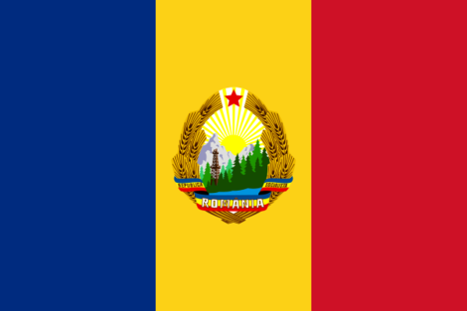

Starting on 17 December 1989, during the revolution at Timişoara, the coat of arms of the Romanian Socialist Republic began to be removed from flags, being viewed as a symbol of Nicolae Ceauşescu’s dictatorial regime. Most often, this was accomplished by cutting or ripping out the middle of the yellow stripe, giving rise to the term "the flag with the hole".
Decree-Law nr. 2 of 27 December 1989 regarding the membership, organization and functioning of the Council of the National Salvation Front and of the territorial councils of the National Salvation Front provided at article 1, among other matters, that “the national flag is the traditional tricolor of Romania, with the colors laid out vertically, in the following order, starting from the flagpole: blue, yellow, red”.
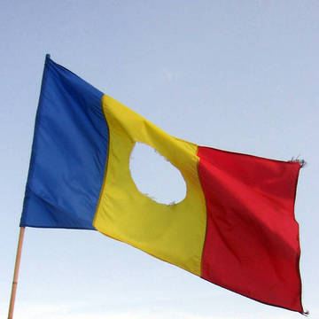

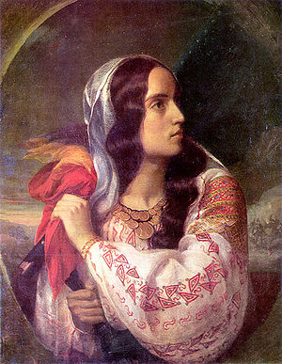

“Revolutionary Romania” . Painting by C. D. Rosenthal.

LOVE OF COUNTRY IN PAINTINGS

Constantin Daniel Rosenthal
Born in 1820, into a Jewish merchant family, with Romanian roots, in Pest (part of the Austrian Empire at the time), he left the city at the age of seventeen in order to attend the Vienna Academy of Fine Arts, where he studied archaeological drawing (graduating in 1839) and made his first Romanian acquaintance, the painter Ioan D. Negulici.
Rosenthal arrived in Bucharest, the capital of Wallachia, around 1842, where he was probably commissioned to pay the first in a long series of boyar's portraits. He was introduced to the liberal-radical circles by Negulici, becoming very close to C. A. Rosetti.
Dissatisfied with his oil painting technique, he left for France in late 1844, he attended art courses in Paris, and began attending meetings of Wallachian and Moldavian students who expressed nationalist and radical ideals.
His most celebrated paintings, two national personifications — România revoluţionară ("Revolutionary Romania", which was also a portrait of Maria Rosetti) and România rupându-şi cătuşele pe Câmpia Libertăţii ("Romania Breaking off Her Chains on the Field of Liberty") —, date from 1850
"[Rosenthal was] one of the best and the most loyal people that God created after His image. He died for Romania, for its liberties; he died for his Romanian friends. [...] This friend, this son, this martyr of Romania is an Israelite. His name was Daniel Rosenthal." Ion C. Butnaru, The Silent Holocaust: Romania and Its Jews, Praeger/Greenwood, Westport, 1992, p.13
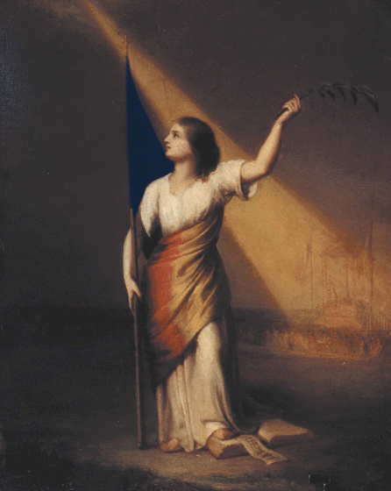

“Romania Breaking off Her Chains on the Field of Liberty”, (România rupându-şi cătuşele pe Câmpia Libertăţii), painting by C. D. Rosenthal.

Teodor Aman- Romanian painter, sculptor and printmaker

Theodor Aman (born on March 20, 1831, at Câmpulung-Muscel–died on August 19, 1891, Bucharest) was a Romanian painter of Armenian descent. His style is often considered to be a predecessor of Impressionism.
After mastering the principles of painting in Craiova and Bucharest, where he studied under Constantin Lecca (1807-87) and Carol Valstein (1795-1857), he left for Paris around 1850. There he attended the studio of Michel-Martin Drolling and, after Drolling's death, that of Fran?ois-Edouard Picot. In 1853 he made his public d?but at the Paris Salon with a Self-portrait (Bucharest, Mus. A. Col.). A year later he travelled to Constantinople (now Istanbul), where the Sultan bought his painting the Battle of Oltenita (1854; Istanbul, Dolmabahce Pal.). Aman then went to the Crimea, where he documented the Battle of Alma (Bucharest, N. Mus. A.) in a painting shown at the Exposition Internationale in Paris (1855). The autumn of the same year and the spring of the following year were spent in Wallachia, where the prince, Barbu Stirbei, honoured Aman with a minor nobiliary title and a grant to enable him to continue his studies in France. In September 1856, after an interval in Italy, he finally returned to Romania, thereafter leaving only sporadically. He is buried in Bellu cemetery.

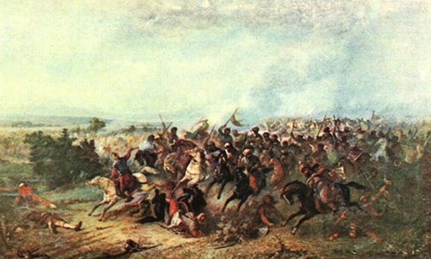
“Banishing the Turks at Călugăreni” Izgonirea turcilor la Calugareni- Teodor Aman
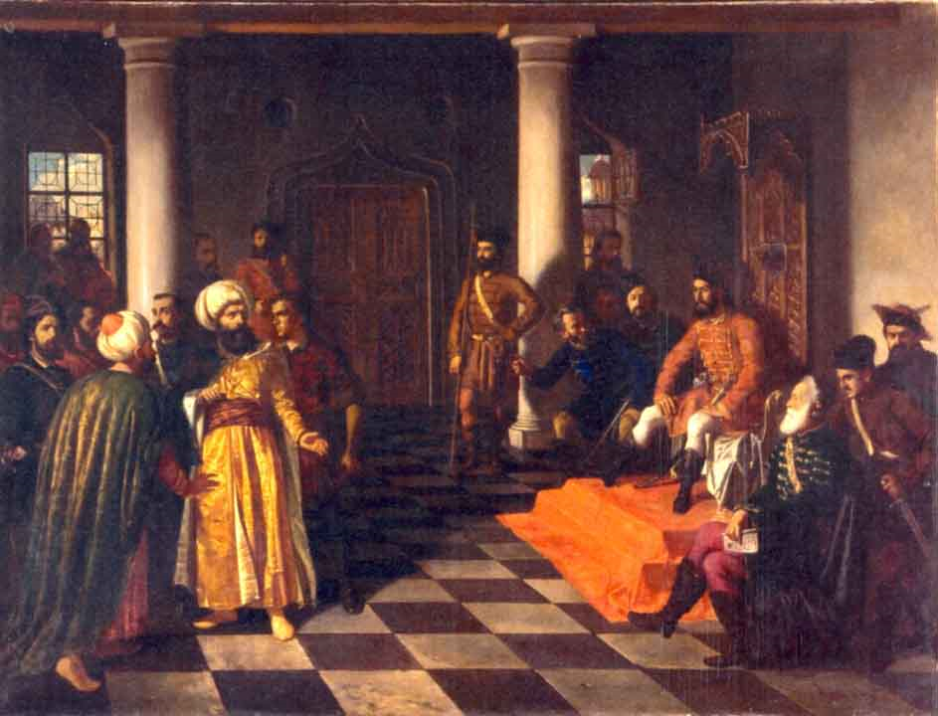

“ Vlad Țepeș and the Turkish envoys” “Vlad Ţepeş şi solii turci”, by Teodor Aman

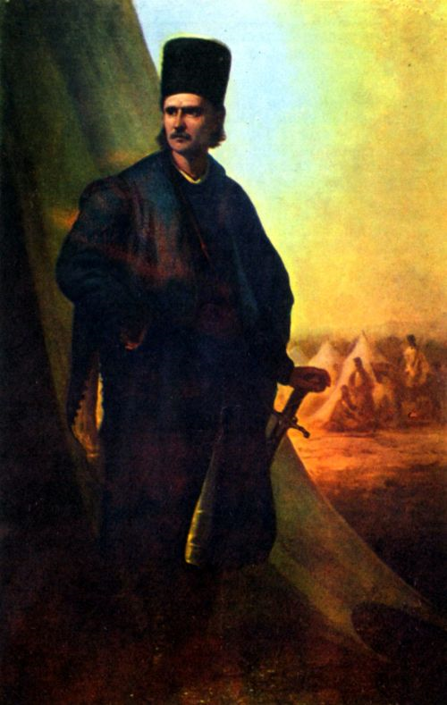
“ Tudor Vladimirescu” - Teodor Aman

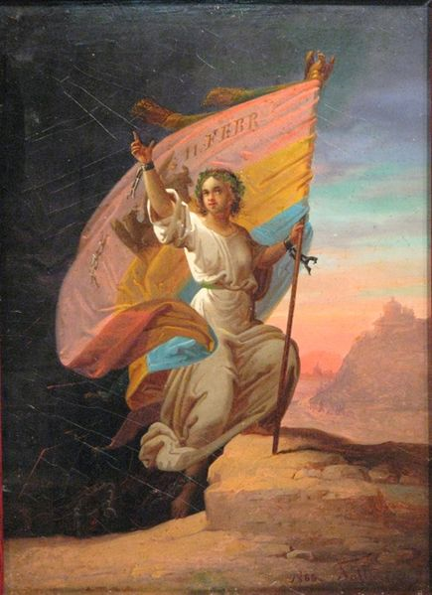

11 februarie 1866- “Modern Romania” “Romania moderna”– by Gh. Tattarescu

Gheorghe Tattarescu was born in Focşani in 1818. He started out as an apprentice to his uncle Nicolae Teodorescu, a church painter. He went on to study at the Painting School from Buzău, when Teodorescu moved there. The Orthodox Bishop of Buzău, Chesarie, helped him obtain a scholarship in Rome, where he was taught by professors from the Accademia di San Luca. While there, Tattarescu made copies paintings by Raphael, Bartolomé Estéban Murillo, Salvatore Rosa, and Guido Reni.
Tattarascu was a participant in the 1848 Revolution in Wallachia. After the revolution, he painted portraits of Romanian revolutionaries in exile such as Gheorghe Magheru, Ştefan Golescu, and, in 1851, that of Nicolae Bălcescu (in three almost identical versions). Romantic nationalist ideals were the inspiration for his allegorical compositions with revolutionary (Romania's rebirth, 1849) and patriotic (“The Principalities' Unification”, 1857 and “February 11th – The Modern Romania”, 1866) themes.
In 1860, being commissioned to draw up a National Album of sights and historical monuments of the country, his talent of painting vaguely Romantic landscapes became highly valued. At the same time, showing his sympathy with various peasant uprisings, he painted “The peasant at the Danube” in 1875. He was also commissioned to decorate several churches in a neoclassical manner.
In 1864, together with painter Theodor Aman, Tattarescu founded the National School of Fine Arts in Bucharest; he was a professor there for a long time after, and served as the School's headmaster for two years (1891-1892).
In 1865, he wrote Useful Principles and Studies on Proportions of the Human Body and Drawing after the Most Famous Painters.
Tattarescu died in Bucharest. The house he bought in 1855 and lived in for almost 40 years is now home to the Gheorghe Tattarescu Memorial Museum. It was opened 1951, and hosts several of his original works of art.

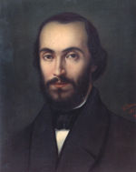

Gheorghe Tattarescu: Nicolae Bălcescu (1851)

#Nicolae Grigorescu- the most important Romanian painter of XIX th century

He was born in Pitaru, (judeţul Bihor), Romania. In 1843 the family moved to Bucureşti. At a young age (between 1846 and 1850), he became an apprentice at the workshop of the painter Anton Chladek and created icons for the church of Băicoi and the monastery of Căldăruşani. In 1856 he created the historical composition Mihai scăpând stindardul (Michael the Brave dropping the flag), which he presented to the Wallachian Prince Barbu Ştirbei, together with a petition asking for financial aid for his studies.
Between 1856 and 1857, he painted the church of the Zamfira monastery, Prahova county, and in 1861 the church of the Agapia monastery. With the help of Mihail Kogălniceanu, he received a scholarship to study in France.
In the autumn of 1861, young Grigorescu left for Paris, where he studied at the École des Beaux-Arts. He also attended the workshop of Sébastien Cornu, where he had as a colleague Pierre-Auguste Renoir. Knowing his weaknesses, he concentrated drawing and composition. However, he soon left this workshop and, attracted by the artistic concepts of the Barbizon school, he left Paris for that village, where he became the associate of artists such as Jean-François Millet, Jean-Baptiste Camille Corot, Gustave Courbet and Théodore Rousseau. Under the influence of the movement, Grigorescu looked for new means of expression and followed the trend of en plein air painting, which was also important in Impressionism. As part of the Universal Exposition of Paris (1867), he contributed seven works. Then he exhibited at the Paris Salon of 1868 the painting Tânără ţigancă (Gypsy girl).
He returned to Romania a few times and starting in 1870 he participated in the exhibits of living artists and those organized by the Society of the Friends of the Belle-Arts. Between 1873 and 1874 he traveled to Italy, Greece and Vienna.
In 1877 he was called to accompany the Romanian Army as a "frontline painter" in the Romanian War of Independence. During the battles at the Grivica Strongpoint and Oryahovo, he made drawings and sketches which later used in creating larger-scale works. In 1889 his work was featured in the Universal Exhibition in Paris and at the Romanian Atheneum. Centerpiece exhibits took place at the Romanian Atheneum would follow in 1891, 1895, 1897, 1902, and 1905.
From 1879 to 1890 he worked in France, especially in Vitré, Brittany, and in his workshop in Paris. In 1890 he settled in Câmpina and started depicting pastoral themes, especially portraits of peasant girls, pictures of ox carts on dusty country roads and other landscapes. He was named honorary member of the Romanian Academy in 1899.
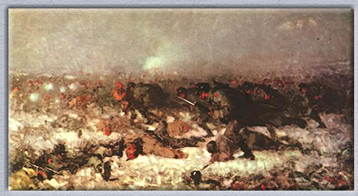
At the moment of his death, Grigorescu had been working on his Întoarcerea de la bâlci (The Return from the Fair).

“The attack from Smȃrdan”
Atacul de la Smardan

by Nicolae Grigorescu

POEMS:

Dati-mi arpa de arama
by George Cosbuc

Daţi-mi arpă de aramă
Dar cu strunele de fier
Căci să cânt acuma cer
Ca un vânt ce se sfaramă
Printre stânci de-ngheţ şi ger.

Voi să cânt în poezie
De-acei timpi urâţi păgâni
Când strămoşii cei bătrâni
Se luptau cu bărbăţie
Şi-i dau nume ,,La români!"
La români! Popor de fală
Cap de geniu, piept de foc
Cu judeţiul de proroc
Dar cu inimă regală
Şi cu flamuri de noroc.

Daţi-mi arpa în rugină
Să mai cânt zguduitor
De-al românilor popor
Şi-de-al ţărei cei române,
Şi de-al secolilor dor!

Patria romana

by George Cosbuc

Patria ne-o fi pământul
Unde ne-or trăi nepoţii,
Şi-ntr-o mândră Românie
De-o vrea cerul, în vecie,
S-or lupta să ne păzească
Limba, legea românească
Şi vor face tot mai mare
Tot ce românismul are:
Asta-i patria cea dragă
Şi-i dăm patriei române
Inima şi viaţa-ntreagă.

Hand me a copper harp

Hand me a copper harp
Made of iron strings
For what I’m asking now is to sing
Just like the wind
Crashing among the rocks for frost and freezing

I want to sing in my poem
Of those ugly pagan times
When our ancient ancestors
Faught with intense bravery
And gave a name to Romanians
Romanians! Glorious people
Head of genius, chest of fire
With the judgment of a prophet
With a royal heart inside
And the streamers of good-luck

Hand me the rusty harp
So I can still loudly sing
Of the Romanian people
And the Romanian country
And the enduring homesickness

The Romanian country

Our country is the land
Where our grandsons will live
And, in a proud-hearted Romania,
May God wish it so
They will forever strive to guard
Our Romanian language and customs
And forever will enlarge
All the greatness of Romania
This is our dear land
And we’ll give to our country
Our lives and hearts at hand.

SONGS:

Țara mea

Tudor Gheorghe

Acolo unde-s nalţi stejari
Şi cât stejarii nalţi îmi cresc
Flăcăi cu piepturile tari,
Ce moartea-n faţă o privesc;

Acolo, unde-s stânci şi munţi,
Şi ca şi munţii nu clintesc
Voinicii cei cu peri cărunţi
În dor de ţară strămoşesc;

Şi unde dorul de moşie
Întotdeauna drept a stat
Şi bărbăteasca vitejie
A-mpodobit orice bărbat;

Acolo este ţara mea,
Şi neamul meu cel românesc!
Acolo eu să mor aş vrea,
Acolo vreau eu să trăiesc!

My country

Tudor Gheorghe

Where the tall oaks grow
And, as tall as them,
My youngsters proudly show
To actually face death

Where the rocks and mountains are
And, standing still like them,
The grey-haired, valiant men
Yearning for our country’s land

And where the yearning for the land
Has always stood just
And manly bravery
Has always been our trust

That is where my country lies
And where my people stand
It’s there where I’d like to die
And to live I demand.

http://www.youtube.com/watch?v=WWuPJziaPsw

LOVE MOM

DRAGOSTEA DE MAMA

Quiero mama
Amore mamma
Обичам майка
Μαμά αγάπη
Aşk anne
Liefde moeder
Rakkaus äiti

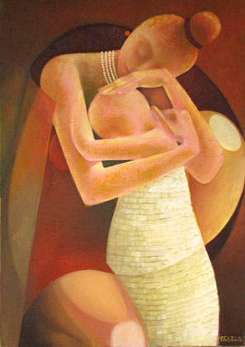

Rodica Toth Poiata- “Mother with her child”- Mama cu pruncul

The Enduring Love of a Mother

Mother’s love is the first sacred, unbroken link of relation ships we will ever know. The most pure and everlasting bond we will ever share in life. When all other relationships fail, the connection of a mother and child stand the test of all times. She is the first one to hold our hands and guide us, feed and nurture us. The most lovable and affectionate person we can relate to on earth. Mother is the representation of God on earth. When we fall, she picks us up. When we are in pain, she takes the pain. When we are condemned, she strengthens us. We never can repay the love of a mother.
The very sight of our mother means the world to us. Everything a mother does is special to us. We love to hear the things she speaks, the food she cooks, the stories she tell; everything that concerns us. Nothing can taste better than the taste of her cooking. We look forward to enjoy our heartiest meal from the work of her hands.
We are thrilled at her happiness: the way she dresses, the things she does, and most importantly the love she gives. Her love gives us the greatest inspiration. She is the source from which we build beautiful dreams to make her proud. We want to fulfill her deepest wishes. She is the treasure of life.
Nothing or no one in this world can be compared to our mother. This bond cannot be broken in life or death. A mother is a priceless possession for all times. Regardless how she may be compared to others, she is always the dearest person in our lives. Her prosperity is our prosperity. Everything that we are is linked to her. Some may want to tell you different, but you know better. A mother’s strength is our strength.
Her love is so powerful; it becomes the essence of our lives. She is always our friend, guide, teacher, counselor, and the first person we learn to trust. No one can take the place of our mothers. Her very presence can enrich us by what she speak and does. She expresses the essence of God in our lives. She will go through the deepest sufferings to uphold those she loves.
We should never take this relationship for granted. We should do everything to make our mothers happy because there will never be another like her. She has the deepest love for us on earth more than any other person we will know. What we gain from her will stay with us forever. She will always love and care for her own and others.
Our mothers are always there to defend and stand by us. She will never be able to bear when we are ill-treated by others. She will prefer to stand in our place and take the pain instead. When we are in pain, she cries out for us, likewise when she is in pain, our whole being want to rescue her. She will endure any amount of suffering to spare her children. Her love is always rich and admirable. Our lives can only know stability from the love of our mothers.
Even though, with our natural mothers, we can have the closest bond, this relationship can also be developed with grandmothers or other kin. A foster mother can also share this relationship. The most important ingredients to share motherly love with someone, are kindness, love, understanding and trust. If we can love with these qualities in mind, then, we can enjoy a rich and enjoyable relationship that is similar to the bond of mother and child.
Our mothers are worthy of much adoration and praise. They never fail in their duties. They are the example we always look up to. In many parts of the world, mothers endure a lot of suffering to abide by their role. We can never forget what she endures for our sake when we were young. She is the example of God, we have on earth and she is irreplaceable.
There has ben written so much on so many approaches regarding Love Mom and Mother’s love, as no one field could stay out of it. The poets, singers, artists have expressed their feelings / opinions towards this matter.
The scientists have also tried to explain how , from the scientific point of view, Mother’s love influence the baby, the mutual love between them.
Scientific studies conclude something mothers everywhere have always intuitively known - that the unique love they have for their offspring is vitally important to their development. A mother's love and nurturing even directly impacts the biological development of the child's brain and central nervous system. In effect, mother and child are "hard-wired" for mutual love. The brain is like a template designed to await molding by its early environment. One researcher even wrote that hugs and kisses during the early critical periods assist in making neurons grow and connect properly with other neurons.

Throughout childhood, warm human love and touch generate an internal release of addicting and pleasurable opiates. Even teenagers (who may act as if they don't need the parents at all) must receive ongoing neural synchrony - love - from the parents. The brain and heart appear literally designed for love, with happiness and even health depending on it.
The pituitary hormone, oxytocin, is present during all loving acts but most especially at birth where it serves to stimulate uterine contractions, and during nursing for the milk ejection reflex. It, along with the nursing hormone, prolactin, help create that intense feeling of love shared by mother and child. Endorphins are physiological chemicals that are also released in both the mother and child during loving contact. They create a feel-good high for both and thus play a critical role in encouraging affection and dependency. When bonding fails, it is theorized that the absence of these pleasure chemicals can leave a void, making such children especially susceptible to drugs that can also release such pleasure chemicals. The stress hormone cortisol is also released when touch and love are lacking. Sensory deprivation in mother-absent children - a form of stress that stimulates the release of cortisol - can increase susceptibility to abnormalities such as depression, violence, substance abuse, and even impaired immune response.
The most natural way mothers deal with newborns in the majority of the world is with an in-arms approach. In more primitive cultures where mothers are barely allowed a break from work to give birth, babies are swaddled to the body creating constant contact and reassurance. This bathes tissues in love hormones and encourages development of healthy neural connections, particularly as the synaptic connections in the cortex develop for the first two years of life.
There is also heart-to-heart, quite literally, between mother and child. Heart muscle cells not only contract, but also communicate with one another. Isolating one cell from the heart in a petri dish causes it to lose its rhythm and begin to fibrillate until it dies. Putting two cells in proximity to one another causes them to synchronize and beat in unison. There is an unseen and as yet unmeasured communication between living cells. The beating of the mother's heart and her breathing pattern coordinate in a critical way with the infant's internal rhythms. This is part of what is known as a synchronizing hormonal flow that occurs between mother and child (directly from breast milk and also from loving contact and even from proximity and thought) that help to regulate vital rhythms in the child. Mothers instinctively place their babies to their left breast, keeping their two hearts close. The mother's developed heart actually stimulates the newborn heart activating a dialogue between the two hearts and minds. Mother and child are more appropriately considered as one, rather than two separate entities as they bond while the child is being held and nursed.
These interesting links that science is revealing between mother and child are another proof that all life is holistic and intimately interconnected. The ideal holistic model is that which nature presents and it is clear that mother and child are meant to be intimate. Children cannot simply be cast off to be fed, clothed and housed as if that were enough. Society needs to take note of this important biology as more and more pressure is put on modern families and mothers to treat newborns as just another duty to schedule into the appointment book or to have serviced by a third party. By giving love the respect it deserves and making it the starting point of life, the odds are much greater that love will then blossom in children and be carried through to their children...and, who knows, perhaps continue on to the world at large. We could use a lot of that.
In art field, there has been shown a great interest on Mother’s Love.

PAINTINGS

Ştefan Luchian

He was born in Ştefăneşti, a village of Botoşani County, as the son of Major Dumitru Luchian and of Elena Chiriacescu. The Luchian family moved to Bucharest in 1873 and his mother wanted to follow his father's path and join the Military School, but instead chose to join in 1885 the painting class at the Fine Arts School, where he was encouraged to pursue a career in painting by Nicolae Grigorescu, whose work was to have a major impact on his entire creation.
Starting autumn 1889 Luchian studied for two semesters at the Munich Fine Arts Academy, where he created copies of the works by Correggio and Rembrandt housed in the Kunstareal. After his return to Romania, he took part in the first exhibition of the Cercul Artistic art group.
He showed himself unable to accept the academic guidelines imposed by the Bavarian and Romanian schools. The following year, he left for Paris, where he studied at the Académie Julian, and, although taught by the academic artist William-Adolphe Bouguereau, became acquainted with impressionist works of art. Luchian's painting Ultima cursă de toamnă shows the influence of Édouard Manet and Edgar Degas, but also echoes of the Société des Artistes Indépendants, Modernism, and Post-impressionism (also obvious in works created after his return to Bucharest).
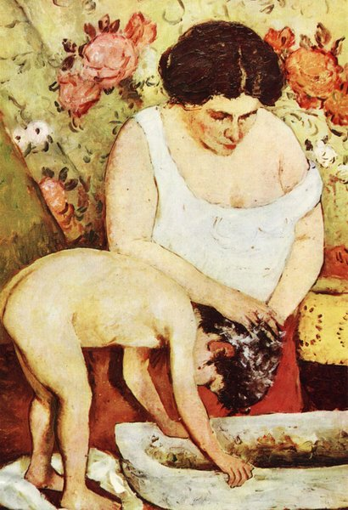

S. Luchian- “Lautul” – Hair washing

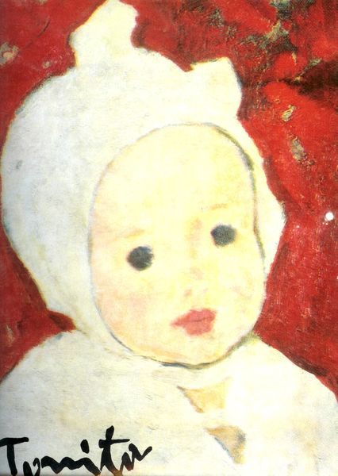

Nicolae Tonitza - “Child head”- Cap de copil

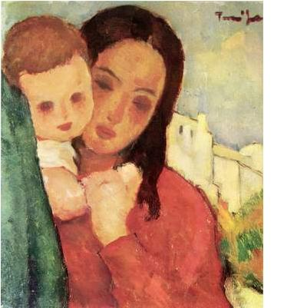

Nicolae Tonitza- “Mother and baby” - Mama si copilul

SCULPTURES

Ion Irimescu- a story of a life

Irimescu was one of Romania's greatest sculptors and sketchers as well as a Member of the Romanian Academy. In 2001 he was awarded the Prize of Excellence for Romanian Culture. He is often referred to as the "patriarch of Romanian art and sculpture".
He was born in Fălticeni, where he was a member of the first graduating class at the Nicu Gane National College. His mother descended from an old French family with claims to aristocracy; she was the granddaughter of Romanian writer Alexandru Cazaban (1872–1966) and Irimescu was thus the nephew of Romanian playwright and director Jules Cazaban (1903–1963) and of his brother Theodor Cazaban (b. 1921), historian and cultural writer. As a child, while he was out at play, he found a grenade from World War I which exploded in his hand and nearly killed him. Though he was eventually healed, this accident nearly destroyed his dream to become a sculptor.
From 1924 to 1928 he studied at the School of Fine Arts in Bucharest, under Dimitrie Paciurea and Oscar Han. In 1928 he made his début at the Official Salon of Painting and Sculpture in Bucharest, becoming a regular participant there. In 1929 he received a scholarship to the Romanian School at Fontenay aux Roses in France and exhibited at the Salon des Artistes Français in Paris.
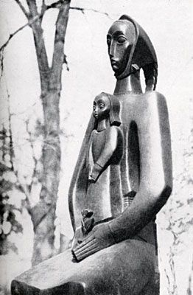
Irimescu became well known not only for his large- and small-scale portrait busts, but also for the neutral stance that he took as an 'official' artist during the years of communist domination. Although he was able to adapt to the forcefully imposed requirements of Socialist Realism (e.g. "Steel-smelter", bronze, 1954), he responded to its abolition by a new creative phase, in which he developed a vegetal morphology inspired by his own calligraphic drawings and the malleability of ceramics. Although Irimescu produced many sculptures in stone, conceived for and erected in public spaces, he concentrated more on modeling and on small-scale sculptures.
One of the dearest theme of the artist was love , the pure love towards mother and her child; this could be seen in works as: “Tribute to mother and child”, “Peace”, “We don’t want war”, “Motherhood”.

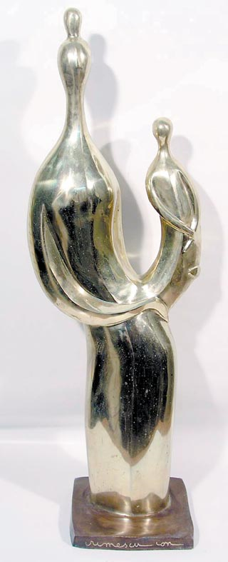

Ion Irimescu- “Mother and child” - Mama si copilul

Ion Jalea- Romanian sculptor.

In 1908, after finishing the Arts and Craftsmanships School, he entered the Belles-arts Academy in Bucharest, where he studied with Professors sculptors Franz Storck and Dimitrie Paciurea. For accomplishing his studies, he went to Paris, at the Julian Academy, to become Bourdelle's apprentice. He was Grand Prize winner at the Paris Exhibition in 1937 and the Barcelone Exhibition . and recipient of National Prize for Sculpture (1941) and State Prize (1957). In 1957 he became people's artist. Member of the Romanian Academy. From 1956 to 1968 he was acting president of the Artists' Union , to become then honorary president of the same Union.
He worked monuments, statues, busts, reliefs and bas reliefs. His vision sprang from an exaltation of form through observing reality -mainly the human face- and from an inclination to assimilate ancient mythology- induced phantastic morphologies. He created highly evoking statues of personalities (Spiru Haret and George Enescu in Bucharest), voyevods' statues of a romantic look (Decebal at Deva; Mircea the Old at Tulcea); the Monument of Railways Heroes, co-worked with sculptor Cornel Medrea; the Emperor and Proletarian reliefs; the Union Obelisque reliefs at Focsani or allegorical representations (Hercules Fighting the Centaur "Herastrau" Park in Bucharest; Pegas, etc.).
Jalea's sculptures, either evoking or romantic, are all ethically motivated: to glorify historical events or personalities, to emphasize moral conduct. He escaped simple illustration which subjects of this kind always invited. His monuments and reliefs obey the classical laws of moderation and harmony, of the proper measure of dynamical elements- gestures, upward and downward diagonals, to create a coherent and static work of art. There is a fine touch over humans, horses (in equestrian statues), imaginary and mythological creatures. They seem to suffer slow vibrations and be light shed. Pictorial draping effects make the anatomical forms transparent. " Archer at sleep" , his most representative work, is the best expression of his talent: a perfect blend of real and allegorical strata, and a perfect knowledge of reconcilation of dynamical and statical strain.

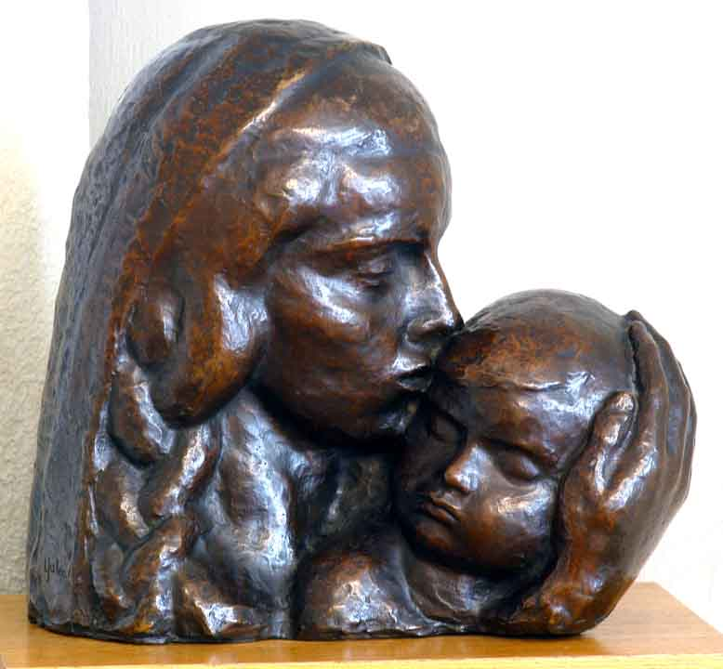 Ion Jalea- “Mother and child”Mama si copilul

SONG: Mama coace pȃine

by Tudor Gheorghe

Mama coace paine
Soare in ferestre
Soarele e unu
Mama una este
Canta un greier din aripa
Greierus, nu tarai
Mama s-a culcat o clipa
Si o poti trezi, trezi
Greierusul fara casa
Uite nu mai tarai,jur
Dar nici frunza sa nu caza
De ce cade ea zurzu.
Mama coace paine
Soare in ferestre
Soarele e unu
Mama una este
Stea, stea logostea
Leagana fetita mea
Ca eu-s tare ocupata
Si ea vrea mult leganata
Stea, stea logostea
Leagana fetita mea
Leagan-o blind si mereu
Stea, stea leganea
Sa creada ca o legan eu
Stea,stea leganea
Leagana fetita mea
Ca eu-s tare ocupata
Si ea vrea mult leganata
Stea, stea logostea
Leagana fetita mea
Mama coace paine
Soare ȋn ferestre
Soarele e unu
Mama una este

Mother bakes the bread

Mother bakes the bread
The sun is at the window
The sun is only one
And only one is mom

A cricket’s playing with its wing
Little cricket, please don’t sing
Mom’s gone to bed for a moment
And you might wake her up in torment
You homeless little cricket
Atop singing, I am begging
If only leaves stopped falling
Why do they fall, I’m wondering

Dear, little, star
Swing my little girl
For I’ve been so busy
And she wants so much cradling
Dear little star
Swing my little girl,
Swing her forever gently
Dear little star
So she thinks it’s me who’s cradling
Dear little star
Swing my little girl
For I’ve been so busy
And she wants so much cradling
Dear, little star
Swing my little girls

Mother bakes the bread
The sun is at the window
The sun is only one
And only one is mom

http://www.youtube.com/watch?v=GuZvmh0S16Y&feature=related

SONG: Mama
by Cargo

Ochii tai, plini de soare si vis,
Mana ta, parul imi mangaia.
Mi-amintesc, fara sa ma gandesc,
Ca prin vis...

Povesteai, vorbe dulci imi spuneai,
De un print si de-un rege vorbeai.
Mi-amintesc, fara sa ma gandesc,
Ca prin vis...

Intr-o seara, ma alintai,
O poveste cum imi spuneai
Si in poala, tu ma tineai
Suradeai...

Spune mama, unde te duci ?

Versuri Cargo - Mama
de pe http://www.versuri.ro
Mama, stai sa ma asculti.
O mama, imbatranesti...
Unde esti ?

Au trecut, cati ani de-atunci
De cand tu, imi povesteai.
Anii trec, nu inteleg,
Fara rost...

Parul tau s-a mai albit.
Mana ta a imbatranit.
Ochii tai sunt ca atunci,
Ca prin vis...

Spune mama, unde te duci ?
Mama, stai sa ma asculti
O mama, imbatranesti...
Unde esti ?
Mother

Your eyes were full of sunshine and dreaming
Your hand used to caress my hair
I remember, without thinking about it
As if I’m dreaming

You’d tell me stories and comforting words
About a prince and a king
I remember, without thinking about it
As if I’m dreaming

One night you’d caress me
While telling me a story
And in your arms you’d carry me
Smiling

Tell me mother, where are you going?
Mother, stay and listen to me
Oh mum, you’re getting older
Where are you?

How many years have passed since then?
Since you used to tell me stories,
Years go by, I don’t understand why
It’s meaningless to me

Your hair is whiter
Your hand is older
Your eyes are still as they used to
As in a dream

Tell me, mother, where are you going?
Mother, stay and listen to me
Oh mum, you’re getting older
Where are you?

http://www.youtube.com/watch?v=zS0LUqGZ0_I

Loving quotes about mothers and their love....

To a child's ear, "mother" is magic in any language.
- Arlene Benedict, For Mother with Love

********************
God sees us through our Mothers' eyes and rewards us for our virtues.
- Ganeshan Venkatarman, Indian philosopher

********************
Life began with waking up and loving my mother's face
- George Eliot, English novelist

********************
Mother is the name of God in the lips and hearts of children.
- William Makepeace Thackeray, English novelist

********************
A mother is she who can take the place of all others.
- Cardinal Mermillod

*******************
A mother's love is instinctual, unconditional, and forever.
- unknown

********************
Mother is the bank where we deposit all our hurts and worries.
- unknown

********************
My mother's love for me was so great I have worked hard to justify it.
- Marc Chagall

********************
Mothers are instinctive philosophers.
- Harriet Beecher Stowe
********************
She's my teacher, adviser, and greatest inspiration.
- Whitney Houston

********************
A good mother is worth hundreds of schoolmasters.
- George Herbert

********************

A mother loves her children even when they least deserve to be loved.
- Kate Samperi, "Mothers"

********************
There is no substitute for mother.
- unknown

********************
Mother is the one we count on for the things that matter most of all.
- Katherine Butler Hathaway, "The Journals and Letters of the Little Locksmith"

********************
A mother understands what a child does not say.
- Jewish proverb

*********************
Mother's love is peace.
It need not be acquired, it need not be deserved.
- Erich Fromm, psychologist

*********************
All I am I owe to my mother.
- George Washington, first U.S. president

********************
Mother is the home we come from.
She is nature, soil, ocean.
- Erich Fromm, psychologist
********************
God could not be everywhere and therefore He made mothers.
- Jewish Proverb

*********************
Mothers are the necessity of invention.
- Calvin

*********************
The mother's heart is the child's schoolroom.
- Henry Ward Beecher

**********************
Of all the rights of women, the greatest is to be a mother
-Lin Yutang

Applications:

LOVE OF COUNTRY

Topics :

Encourage children to love their country so they will have respect someday as a citizen. This is the best way to set a positive example. As children grow older, explain to them why you feel they should hold their country in high regard. Remember that blind patriotism can be dangerous. Encourage your children to use their minds.

Don't be prejudiced or biased. Every country, religion, or racial group has its own beliefs. Like them you have your own so respect yours and respect them for theirs.

Abusing your country or taking advantage of any of its systems or programs is not a good way to show your love. Such corrupt action goes against the goodwill that should be at the core of your patriotism.

You certainly do not have to agree with every event and decision made in your country's history to love your country. Consider how the country recovered from mistakes, as well as its ideology as described in some guiding document (such as a constitution). Although such principles are not absolute, reflect on whether these precepts are conducive to a government you think would act with its citizens -- and humanity's -- best interests at heart.

Related discussions over:

- How to resist nationalism
- How to go all out on Patriotic Day
- How to enjoy being an expatriot
- How to compare countries with economic political systems

LOVE MOM

- Essays on “Love Mom”
- 1o Different ways to say: “I love you mother”
- Great gift ideas for Mother’s Day
- Mother’s Day greeting cards
- Mother love poems; Love poems for Mother

