BÜYÜKÇEKMECE

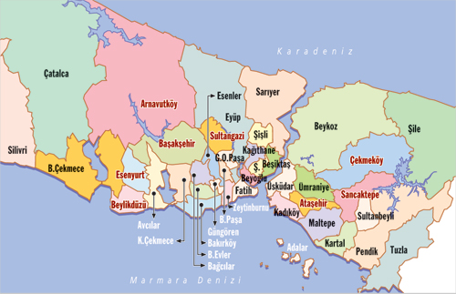

Istanbul/Turkey Map
Büyükçekmece is a district in the suburbs of Istanbul, Turkey on the Sea of Marmara coast of the European side, west of the city. It is largely an industrial area with a population of 380,000.

History
The land around this inlet of the Sea of Marmara, has been settled, abandoned and resettled throughout history as army after army passed along the coast to Istanbul. It is thought to be the site of the Greek colony on the Marmara shore called "Athyra". The Ottoman architect Mimar Sinan built a bridge to cross the mouth of the inlet (Lake Büyükçekmece) and there are ruins of inns and caravansarai, which show this was a stopping place on the road to Europe. At the beginning of the Ottoman period, it was empty forest and farmland, and has gradually been settled by Turkish people migrating in from the Balkans and the Caucasus.
In the early years of the Turkish Republic, it was still very rural, with village cottages, farmland behind, and by the sea the odd weekend home for people of Istanbul. The area was a very popular day or weekend trip from the city, there is a sandy shoreline, a long seafront and until the 1970s families would come out to Büyükçekmece for fishing, crabbing or for a day on the beach.

Büyükçekmece Today
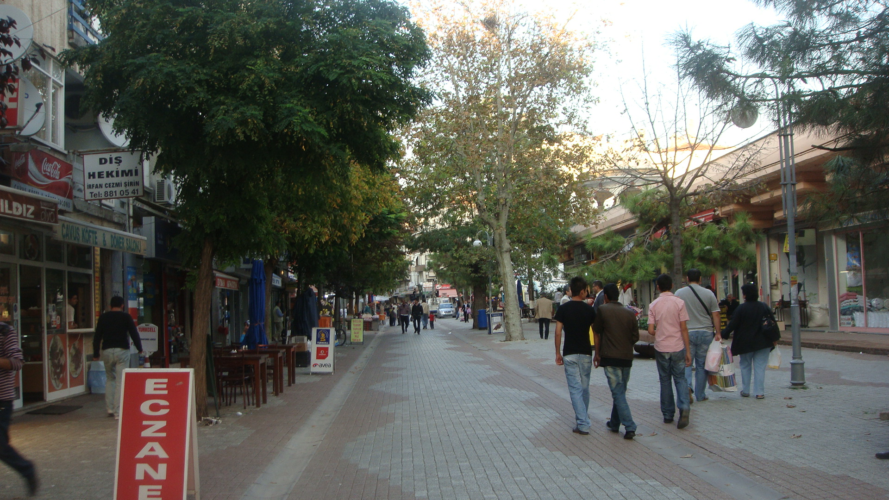

The area administered by Büyükçekmece includes a large hinterland behind the Marmara shore, some of it still rural.
In the centre of Büyükçekmece itself, there are still tea gardens on the seafront and other places for kids to play while their families sit, picnic and enjoy the sea views. These are now used by day trippers from the city, especially the nearby dense working-class housing areas such as Avcilar.
There are no holiday-makers now, they have moved further out from the city as since the 1950s the area has become industrialised, over-built with apartment buildings, and populated by migrants from Anatolia. Today, the inlet and the Marmara Sea are both very polluted and the infrastructure of an industrial city is now in place.
Lake Büyükçekmece was connected to the sea until it was separated by a dam to supply fresh water to Istanbul. The bridge of Mimar Sinan is located in this area.

Enver Pasha’s Mansion

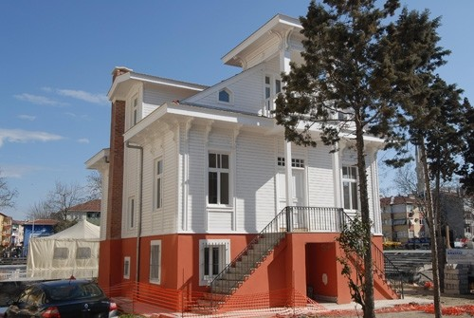

The mansion once inhabited by enver pasha.

Turkish Bath

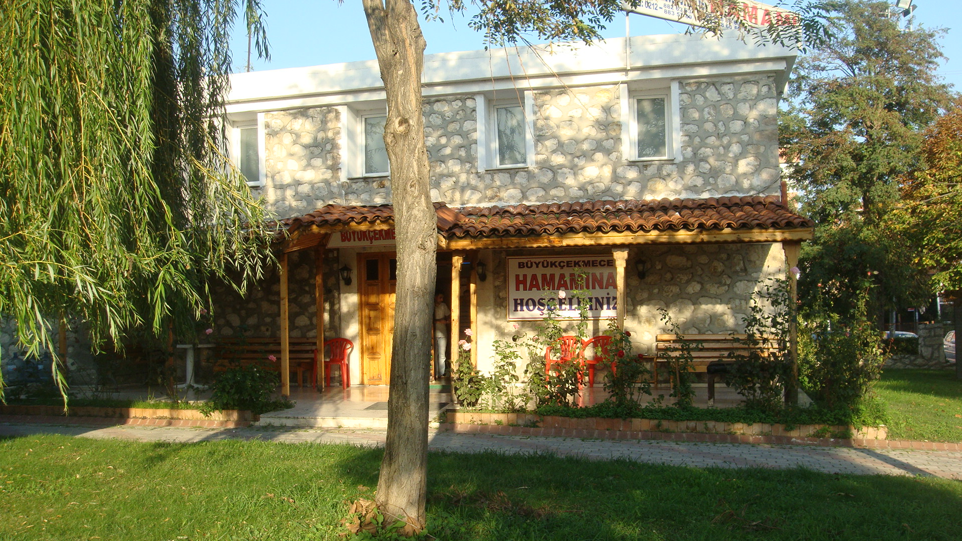

Turkish Baths are in the Culture Park.

The tradition of the Turkish bath extends far back, to a time before Turks had reached Anatolia. When the Turks arrived in Anatolia, they brought with them one bathing tradition, and were confronted with another, that of Romans and Byzantines, with certain local variants. The traditions merged, and with the addition of the Moslem concern for cleanliness and its concomitant respect for the uses of water, there arose an entirely new concept, that of the Turkish Bath. In time it became an institution, with its system of ineradicable customs.

For the Turkish bath was much more than just a place to cleanse the skin. It was intimately bound up with everyday life, a place where people of every rank and station, young and old, rich an poor, townsman or villager, could come freely. Women as well as men made use of the "hamam", as the bath is known in Turkish, although of course at separate hours.

Leaded Han

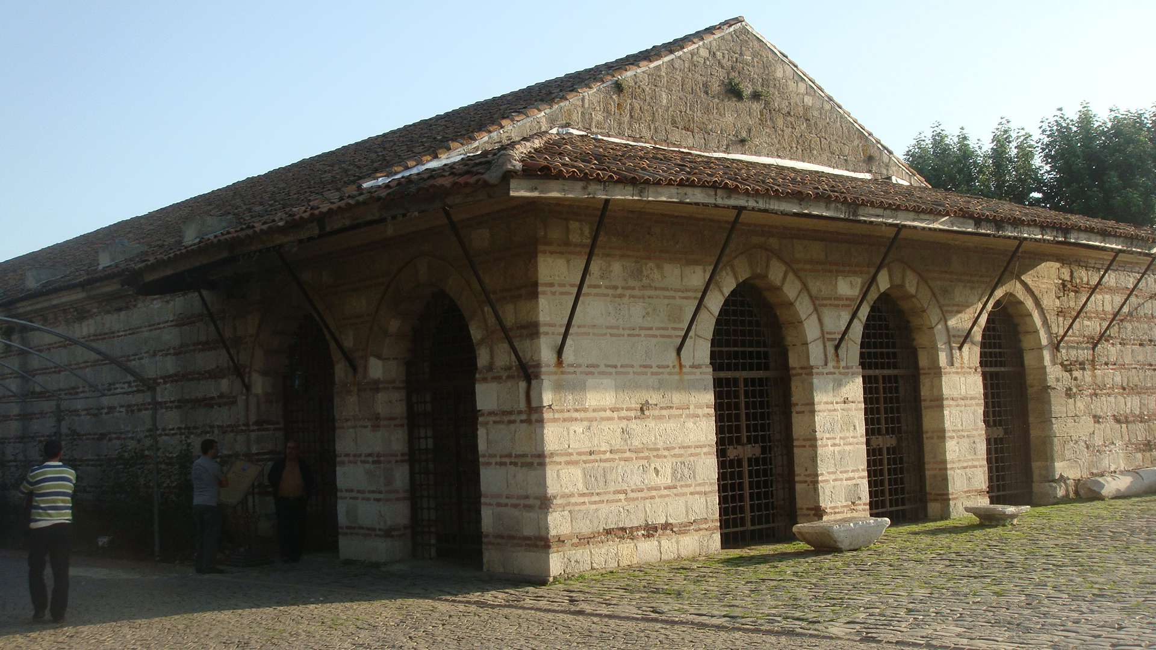

Leaded Han is in the Culture Park.

Leaded Han, Büyükçekmece district in Istanbul on the caravanserai. Known as Büyükçekmece Caravanserai.
Mimar Sinan in 1566 by Sultan Suleyman the Magnificent was built to. 48 meters long, 22.3 meters wide was built of hewn stone caravanserai. The entire roof has been closed when the first bullet is known as Han Kurşunlu.
16. century during the Ottoman Empire, Asia and Europe over trade routes in Istanbul's European exit was a great place to stay.
Was restored in the years 1985-1987 during the month of Ramadan festivities at the caravanserai is made, such as the bazaar and show the cultural and artistic activities are organized.
Caravanserai, in the face of the Fountain of Sultan Suleyman the Magnificent Sokullu Mehmet Pasha Mosque and the Sultan Suleyman the Magnificent in conjunction with the head of the bridge is located in the tourist area.

Mimar Sinan Bridge

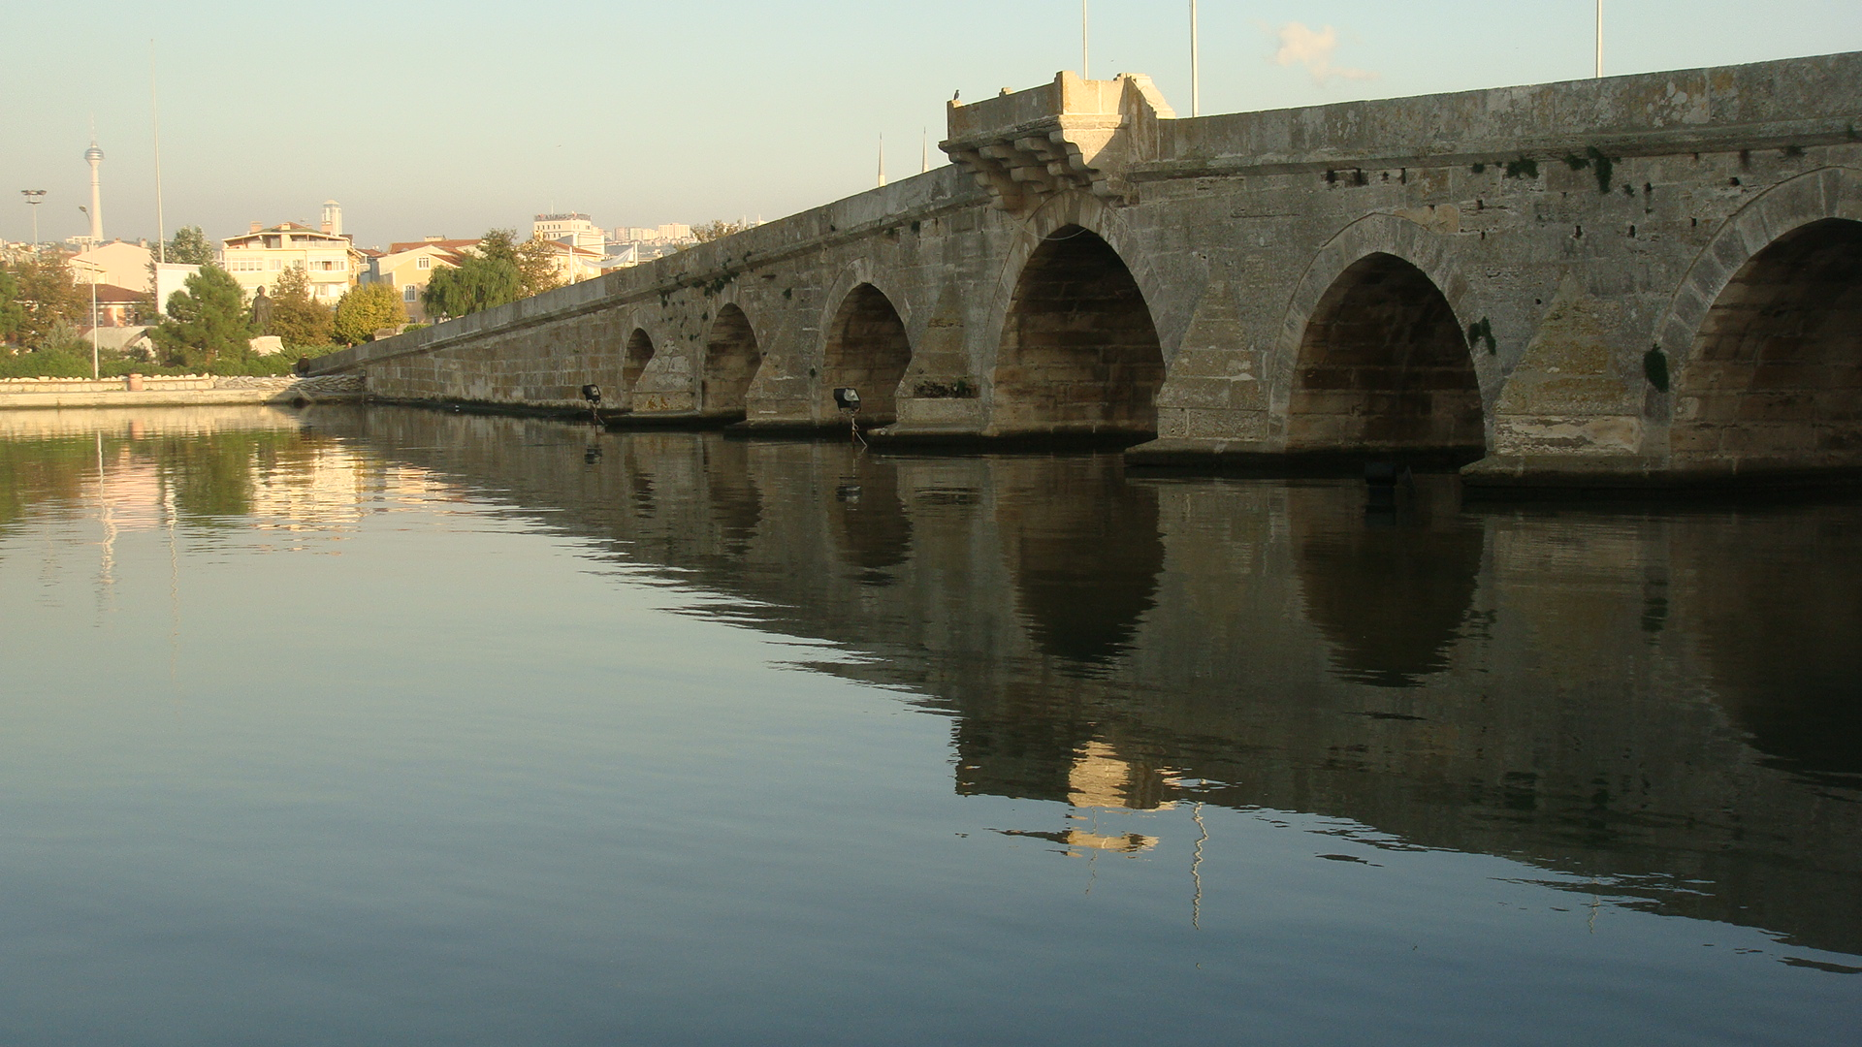

Recognized by the world admire, the famous Ottoman architect Sinan's works of construction of the bridge, while Süleymanic Szigetvár expedition began in emriyele. Bridge II. Selim between the years 1566-1567 was completed on time and 73,853 reserve has been spent. In the construction of the bridge and hundreds Neccar senktraş worked, lake water were taken with a huge pump. Among the piles in the neck knife Temllere 2-3 people streamed to the lead is combined. This basic method and later by the architect Davut Agha was also applied in the new mosque construction. Mimar Sinan Bridge 635 mt. long, 7:17 mt. wide and the unification is composed of 4 separate blinds.

Sokkullu Mehmet Pasha Mosque

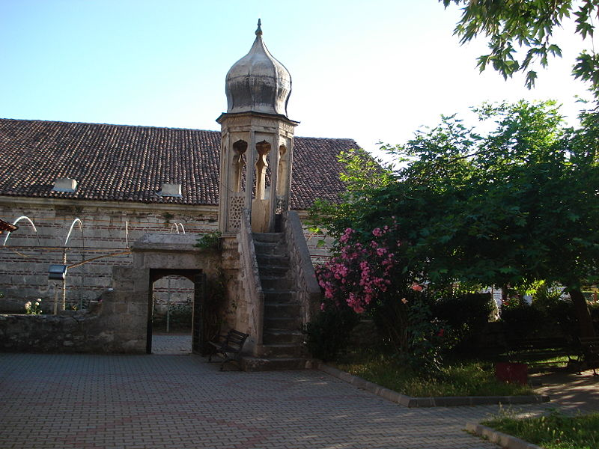

Due to the space available, as is known Köprübaşı Mosque. Mimar Sinan is one of the works. Sokullu Mehmet Pasha Mosque, and the bridge near Büyükçekmece Caravanserai form a complex with a miniature range. Very rare in the world look with massive minaret is a special work.

Fountain of Sultan Suleyman the Magnificent

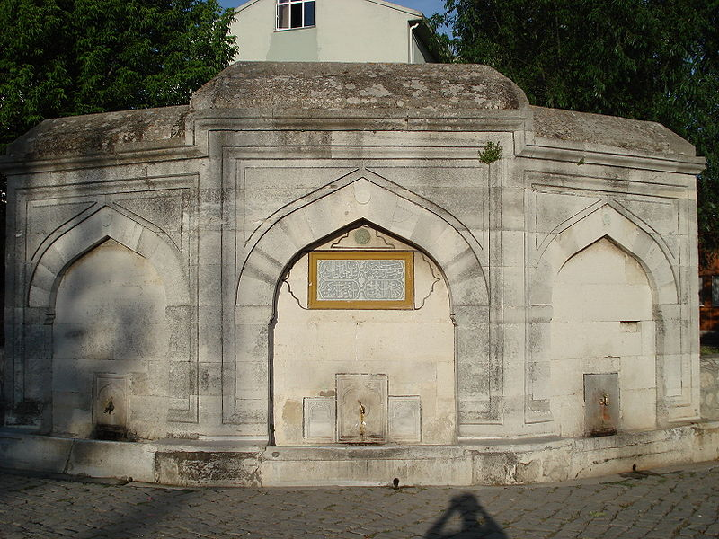

Able to survive in the oldest of Büyükçekmece Köprübaşı fountains at the fountain head is well Sokullu Mehmet Pasa Mosque. The historic bridge was built with and Caravanserai. And in the classical style, built of hewn stone were three wings. Each wing has one fountain and trough in front. Mirror on the stone inscription in verse is written as follows: "How was it that çeşmesarı building / victorious Sultan Süleyman Han / bidi moment of history, the People of the date / ab is the universe still Akdik Kevser / year 974 (Gregorian 1566) is dated as.

Culture Park

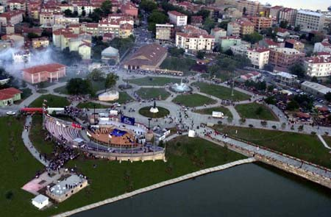

Mimar Sinan's works of the historic bridge, caravanserai, mosques and fountain also located within a park that is built on an area of 200.000 m2. Historical artifacts, as well as in the conservatory has been made by our municipalities, museums, marquee (tent), 5000-person multi-purpose theater amplifier, local cafes in the form of houses, the navigation areas, sports complexes and restaurants are created.

Mimar Sinan

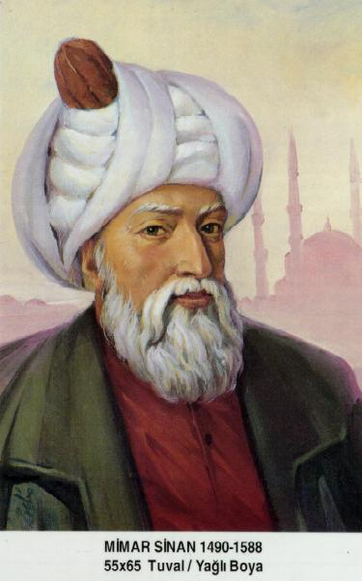

Koca Mimar Sinan Ağa ((15 April 1489 - 17 July 1588) was the chief Ottoman architect and civil engineer for sultans Suleiman I, Selim II, and Murad III. He was, during a period of fifty years, responsible for the construction or the supervision of every major building in the Ottoman Empire. More than three hundred structures are credited to his name, not including some more modest projects, such as his Koran schools (sibyan mektebs).
His masterpiece is the Selimiye Mosque in Edirne, although his most famous work is the Suleiman Mosque in Istanbul. He had under him an extensive governmental department and trained many assistants who, in turn, distinguished themselves, including Sedefhar Mehmet Ağa, architect of the Sultan Ahmed Mosque. He is considered the greatest architect of the classical period of Ottoman architecture, and is often compared to Michelangelo, his contemporary in the West. The stature of Michelangelo and his plans for St. Peter's Basilica in Rome were well-known in Istanbul, since he (and also Leonardo da Vinci) received an invitation to build a bridge over the Golden Horn by the Ottoman Sultan Bayezid II in 1502.

